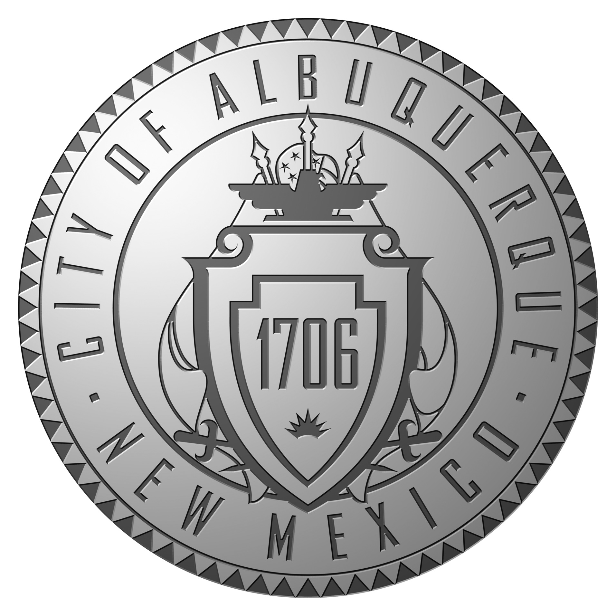
Veterans and Military Affairs Advisory Board

New Mexico Veterans’ Memorial
December 18, 2013
Minutes

- Meeting Called to Order by Roger Newall at 9:10 am
  - Present: Chairman Roger Newall, Vice Chairman Archie Garcia, , Brian Leen, Pat Gaston, Ken O’Keefe, Steve Overman, Louis Tafoya
  - Absent: Steve Asher, Elise Wheeler
  - Pending Members: Gary Zura
- Approval of Minutes from October 16, 2013 Meeting
  - The November minutes were accepted with No Additions or Corrections
- Public Comments – No Public Participation
- Old Business
  - Albuquerque Employee Coins
    - 379 coin requested, 119 not presented to date
  - Hiring Preference
    - The Veterans hiring preference number for 1st 18 months – 700 Interviewed, 200 hired.
  - Membership
    - There are still a few vacancies to fill. Gary Zura will be attending the meeting as a “Pending Member” until the City Approval Process is completed, This could be longer than normal process, but his presence is valuable
  - Projects
    - No new projects were introduced
    - There was continued discussion on providing transportation for veterans to the VA Medical Center
      - Current Proposal was passed out to the members
      - The proposal will only recognize the VA Card as the possible bus pass
  - Legislation
    - Current Vet Contracting Bill doesn’t work as planned, new discussions at the Round House to fix are to be scheduled, maybe?
  - Update Future Events
    - Military Day at the Round House – date possibly Feb 4th?
- New Business
  - Pat Gaston presented information on a Texas plan for awarding college credit for military experience – “College Credits For Heroes”. Is program workable in NM?
  - NM Heroes for Highways program is in effect. Qualified military personal need only take the CDL Knowledge Test to be issued a commercial license.
- Setting of Future Meetings
- Next meeting is scheduled for Wednesday, January 15, 2014 at 9:00 am at the NM Veterans’ Memorial
- Adjourn – 10:20 am

