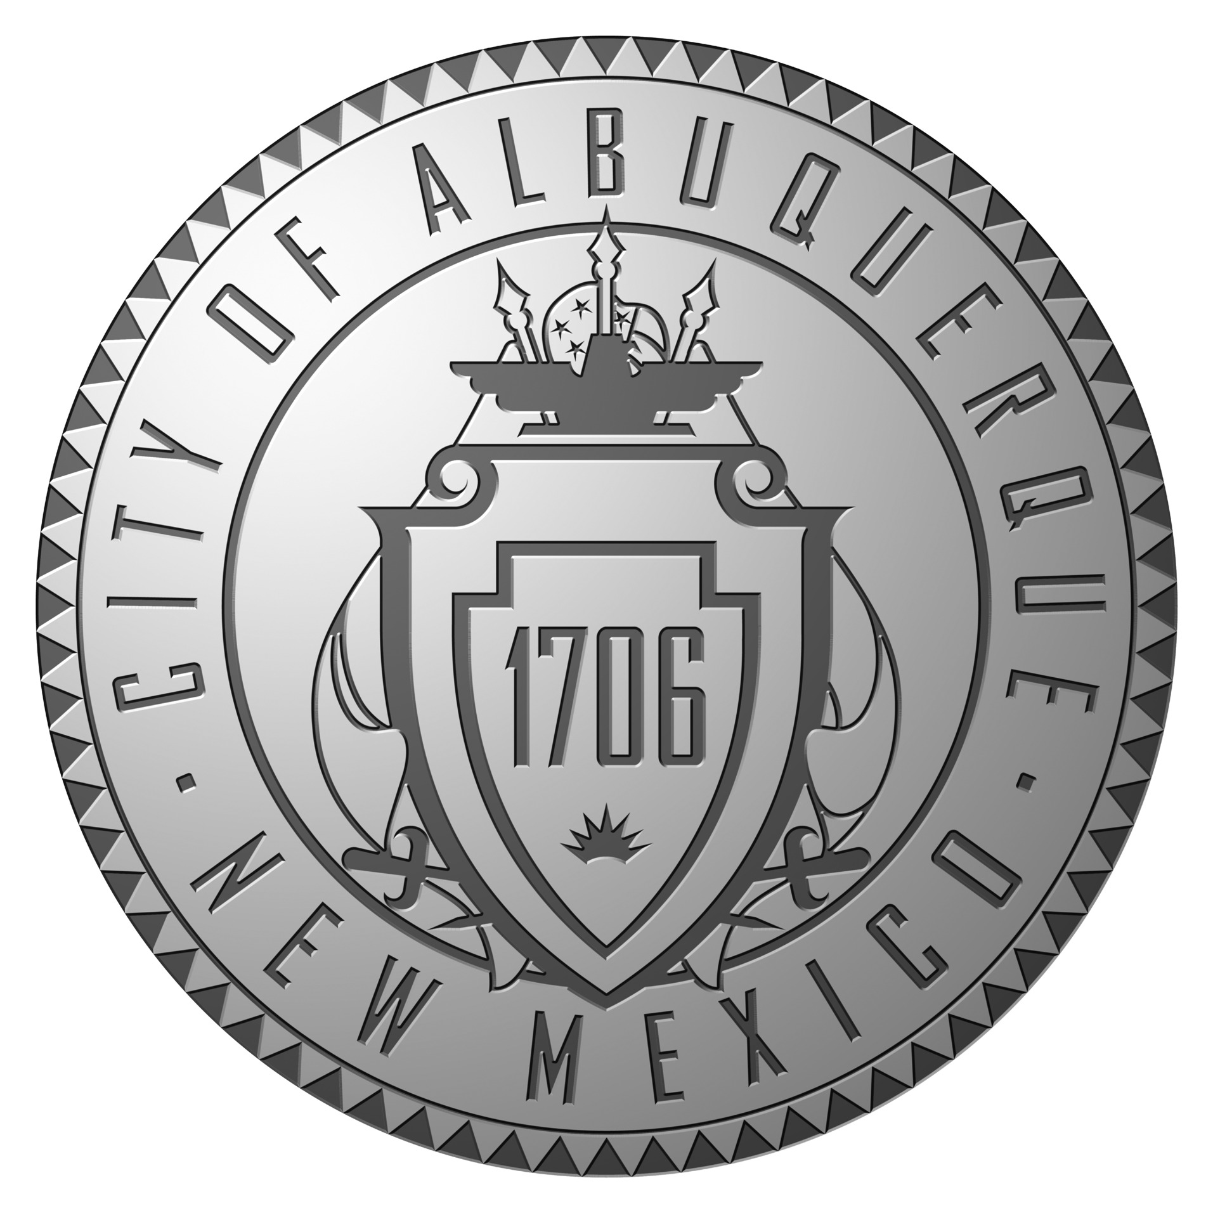
Veterans and Military Affairs Advisory Board

New Mexico Veterans’ Memorial
November 20, 2013
DRAFT
Minutes

- Meeting Called to Order by Archie Garcia at 9:10 am
  - Present: Vice Chairman Archie Garcia, Gary Zura, Brian Leen, Pat Gaston, Steve Asher, Ken O’Keefe, Steve Overman, Louis Tafoya
  - Absent: Chairman Roger Newall, Lloyd Calderon
- Approval of Minutes from October 16, 2013 Meeting
  - The October minutes were accepted with the change of “3,000 homeless veterans in Albuquerque” to “300 homeless veterans in Albuquerque”
- Public Comments – No Public Participation
- Old Business
  - Albuquerque Employee Coins
    - There is not an update on the coins
  - Hiring Preference
    - The Veterans hiring preference seems to be working
  - Membership
    - There are still a few vacancies to fill. New member, Gary Zura, attended his first meeting today
  - Projects
    - No new projects were introduced
    - There was a discussion on providing transportation for veterans to the VA Medical Center
      - Will all veterans be included or target a specific group?
      - Ken O’Keefe believes having a VA Medical system card will be easier to sell to the City
  - Legislation
    - Discussion was held regarding House Bill 87
  - Update Future Events
    - There will be an APD Appreciation Day on 12/13/13 at the Shawn McWethy Substation.
    - Military Day at the Round House – date unknown at this time
- New Business
  - Louis gave Vice Chairman, Archie Garcia, a copy of two business cards; one for Carl Hoffman with NM Dept. of Workforce Solutions and one for J.R. Romero with I CARE. He would like to have them invited to speak at a future meeting
- Setting of Future Meetings
  - Next meeting is scheduled for Wednesday, December 18, 2013 at 9:00 am at the NM Veterans’ Memorial
- Adjourn – 10:00 am

