Department
Responsibility/Role
File Name | input.doc
Revision
Document Generation Date | 8/25/2016 4:25:00 PM
Date Modified | 8/25/2016 10:25:00 PM
Last Changed by
Status

TM-06.4 CABQ - Transferring an Employee Document
Trigger:

Concept

TM-06.4 CABQ - Transferring an Employee Performance Document

When an employee takes a new position with another manager in your department you can transfer the performance document to the new manager. The new manager will be able to update the performance document as appropriate to the new position.

Navigation:
Main Menu>Manager Self Service>Performance Management>Performance Documents>Administrative Task>Transfer Document

Required Field(s) | Comments

Output - Result(s) | Comments

Additional Information

Procedure

In this lesson we will walk through the steps for Transferring an Employee Peformance Document.

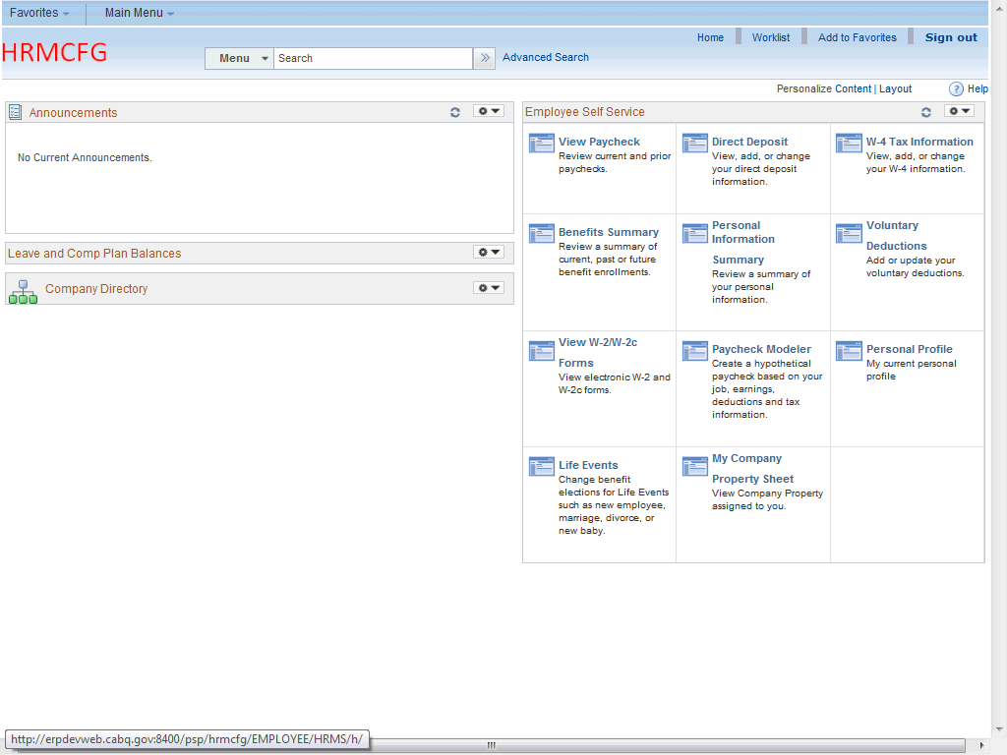

Step | Action
 | Click the Main Menu link to begin navigation.
 | Click the Manager Self Service menu item.
 | Click the Performance Management menu item.
 | Click the Performance Documents menu item.
 | Click the Administrative Tasks menu item.
 | Click the Transfer Document menu item.
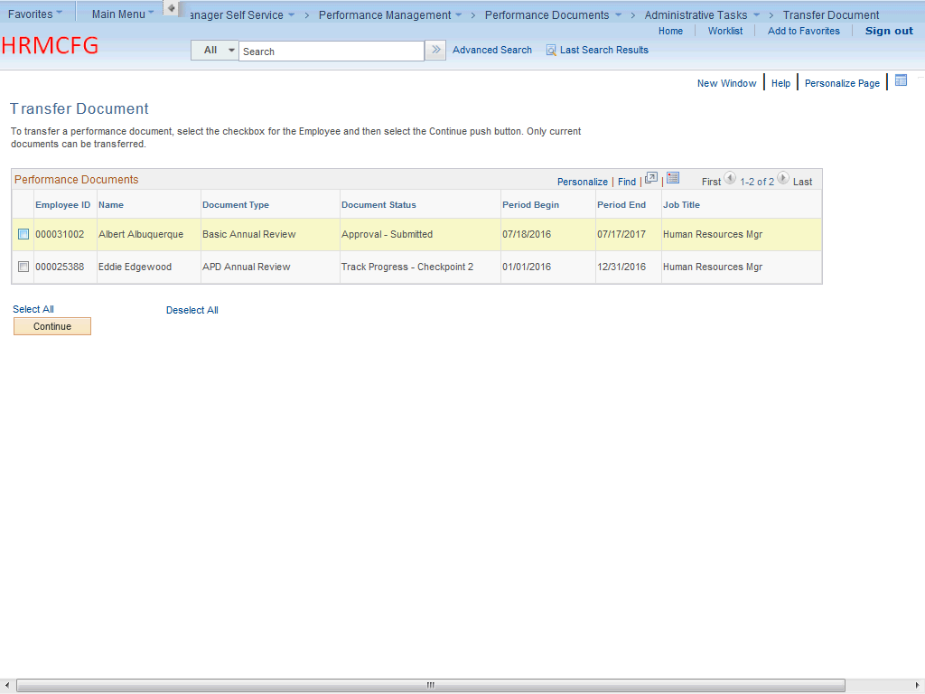

Step | Action
Choose the appropriate employee to transfer by clicking the checkbox on that employee's Performance Document line.

Click the Checkbox option.
 | Click the Continue button.
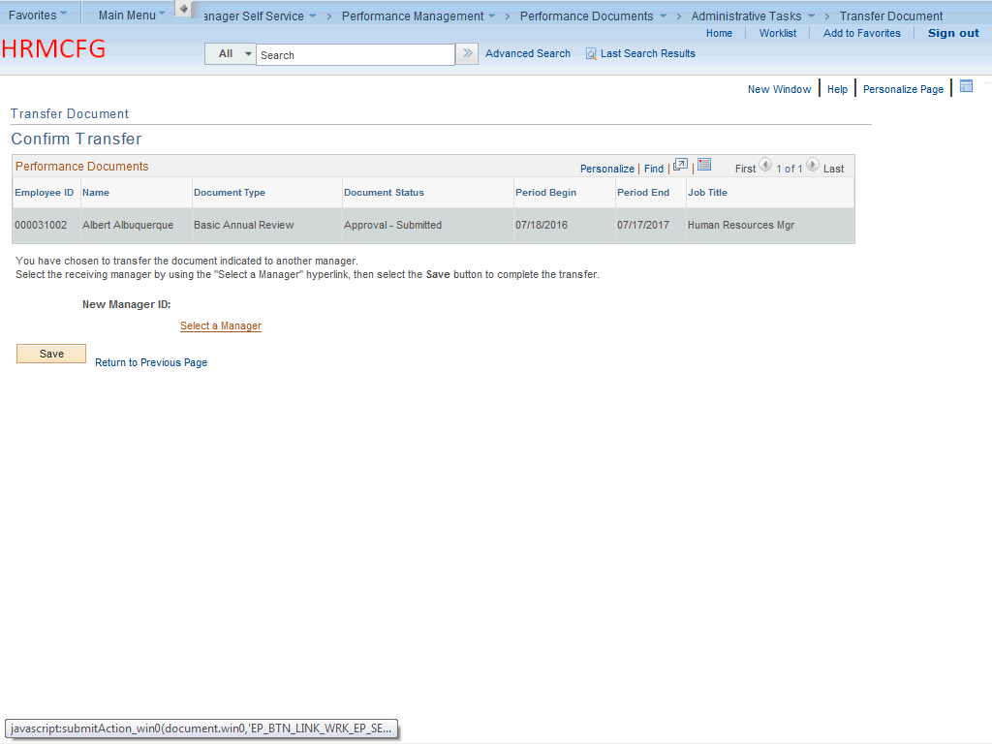

Step | Action
Select the Manager that will be receiving the employee as a direct report.

Click the Select a Manager link.
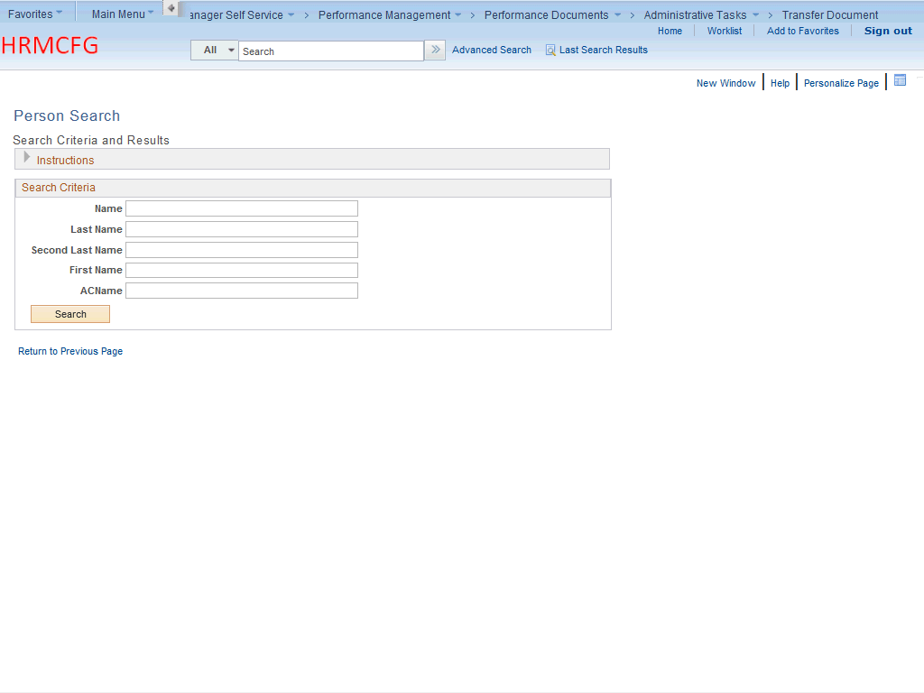

Step | Action
Enter the desired information into the Name field.

For this training, enter "Andrea".
Enter the desired information into the Last Name field.

For this training, enter "Romero".
 | Click the Search button.
Click on the radial button to choose the manager.

Click the Andrea Romero option.
 | Click the OK button.
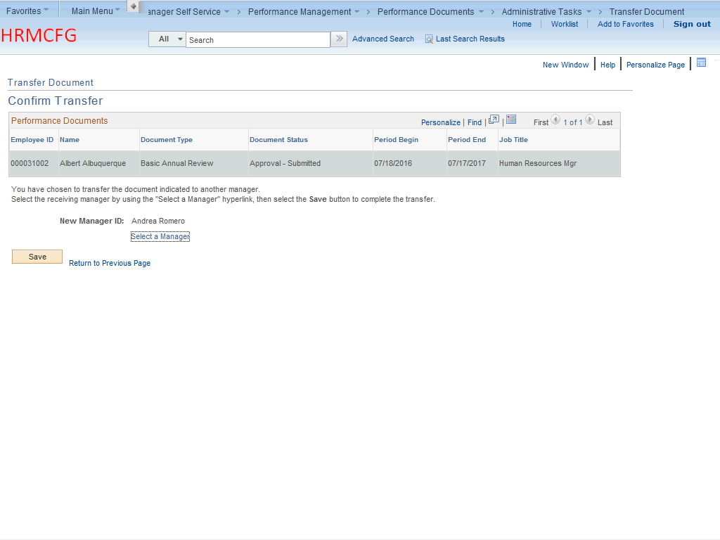

Step | Action
 | Click the Save button.
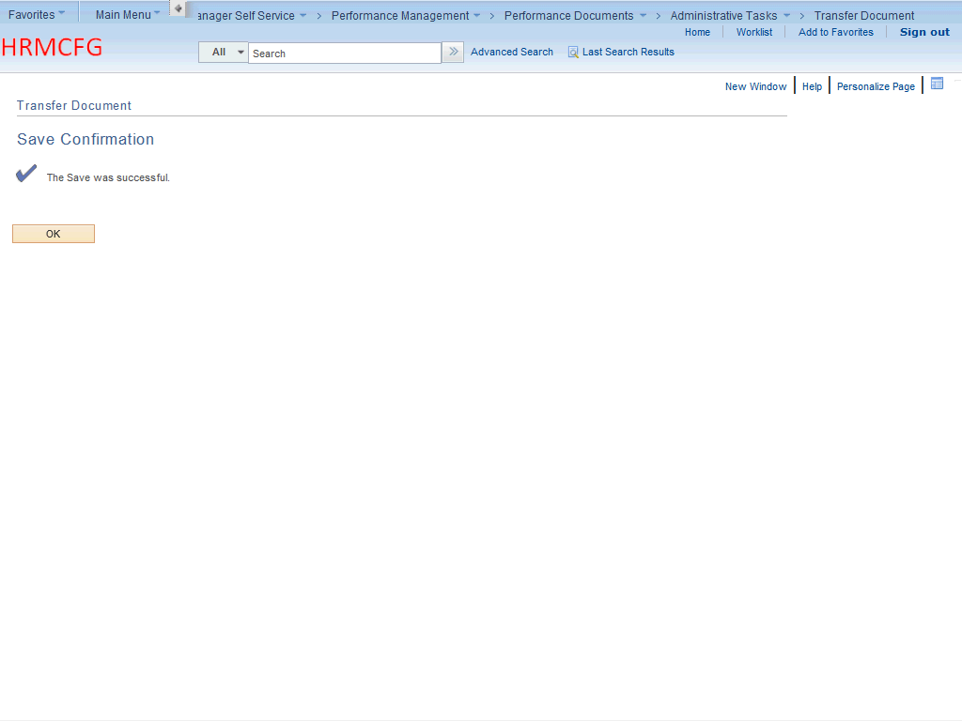

Step | Action
 | Click the OK button.
Congratulations! You have successfully completed Transferring an Employee Peformance Document.
End of Procedure.

