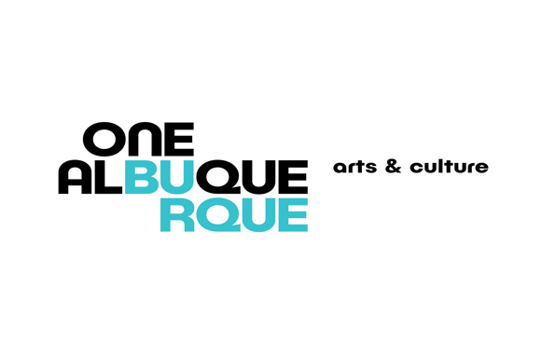 

**Albuquerque Museum Board of Trustees**

MEETING AGENDA

**Tuesday, February 11, 2025, 11:30 a.m. – 1:00 p.m.**

**Albuquerque Museum – Auditorium**

1. Call to Order by Sherri Burr, and Authorization to Record
2. Public Comment
3. Approval of Board Meeting Minutes
   1. December 10, 2024
4. Shaun Nashboo with Board and Commissions
   1. Board Training
   2. Board Quorum Count
   3. Questions and Answers
5. William Gassaway to present purchase of Cannupa Hanksa Luger’s *Muscle, Bone, and Sinew*
6. Appointment of Nominating Committee—Sherri Burr
7. Museum Director Report - Andrew Connors
8. Curators Reports
9. Albuquerque Museum Foundation Report - John Martinez
10. Adjourn

Next Regular Meeting –Tuesday, April 8, 2025, 11:30 a.m. – 1:00 p.m.

**Reasonable accommodations for people with disabilities**

**Please contact** [**abqmuseum@cabq.gov**](mailto:abqmuseum@cabq.gov) **or 505-243-7255**